Приложение №1
к решению Совета депутатов
городского округа Домодедово
Московской области
от 10.06.2021 № 1-4/1133
Карта (схема) корректировки границ населенного пункта с. Ям
городского округа Домодедово

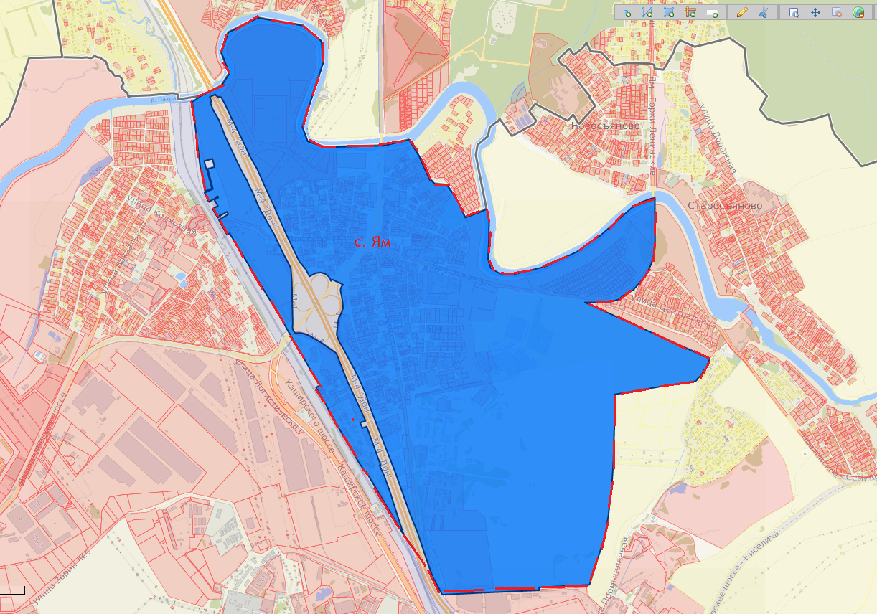

Условные обозначения:

- существующая граница населенного пункта село Ям

- измененная граница населенного пункта село Ям

Приложение №2
к решению Совета депутатов
городского округа Домодедово
Московской области
от 10.06.2021 № 1-4/1133

Геодезические данные измененной границы населенного пункта с. Ям городского округа Домодедово

№ точки | X,м | Y,м
1 | 440418,24 | 2202932,87
2 | 440360,34 | 2203247,20
3 | 440249,13 | 2203374,03
4 | 440102,99 | 2203384,14
5 | 439656,30 | 2203233,41
6 | 439554,28 | 2203269,26
7 | 439512,00 | 2203391,50
8 | 439518,75 | 2203801,31
9 | 439557,96 | 2203978,05
10 | 439444,86 | 2204045,26
11 | 439424,06 | 2204055,09
12 | 439422,76 | 2204053,63
13 | 439276,31 | 2204117,91
14 | 439280,96 | 2204124,26
15 | 439249,39 | 2204150,81
16 | 439239,34 | 2204238,16
17 | 439180,12 | 2204279,96
18 | 439112,79 | 2204319,59
19 | 439011,34 | 2204363,84
20 | 439055,39 | 2204484,19
21 | 439070,26 | 2204514,07
22 | 438988,41 | 2204529,44
23 | 438845,89 | 2204525,88
24 | 438721,31 | 2204519,10
25 | 438657,74 | 2204537,75
26 | 438619,60 | 2204600,48
27 | 438614,52 | 2204703,06
28 | 438664,52 | 2204916,69
29 | 438764,47 | 2205136,80
30 | 438875,71 | 2205302,46
31 | 439067,45 | 2205524,66
32 | 439080,05 | 2205546,12
33 | 439107,28 | 2205592,48
34 | 439131,87 | 2205663,56
35 | 439135,94 | 2205687,57
36 | 439027,55 | 2205687,31
37 | 438890,77 | 2205687,35
38 | 438790,23 | 2205684,92
39 | 438740,30 | 2205676,41
40 | 438700,75 | 2205666,93
41 | 438662,92 | 2205651,91
42 | 438617,12 | 2205629,75
43 | 438559,75 | 2205588,04
44 | 438494,90 | 2205529,57
45 | 438467,11 | 2205479,81
46 | 438452,27 | 2205452,96
47 | 438432,04 | 2205429,88
48 | 438416,39 | 2205377,16
49 | 438410,45 | 2205273,44
50 | 438412,61 | 2205191,55
51 | 438403,99 | 2205210,15
52 | 438332,88 | 2205363,66
53 | 438294,61 | 2205446,27
54 | 438198,60 | 2205653,53
55 | 438122,89 | 2205816,96
56 | 438077,17 | 2205915,66
57 | 438010,18 | 2206060,28
58 | 437999,63 | 2206054,89
59 | 437998,80 | 2206055,86
60 | 437932,20 | 2206025,97
61 | 437935,57 | 2206020,55
62 | 437912,21 | 2206007,70
63 | 437899,47 | 2206000,70
64 | 437892,45 | 2205994,13
65 | 437872,42 | 2205972,01
66 | 437870,18 | 2205974,62
67 | 437855,91 | 2205959,56
68 | 437855,33 | 2205955,46
69 | 437849,73 | 2205915,66
70 | 437835,83 | 2205816,96
71 | 437826,74 | 2205752,38
72 | 437818,89 | 2205703,40
73 | 437801,49 | 2205594,75
74 | 437796,41 | 2205563,00
75 | 437786,08 | 2205498,48
76 | 437768,89 | 2205391,15
77 | 437640,96 | 2205389,93
78 | 437552,16 | 2205389,08
79 | 437417,26 | 2205383,78
80 | 437282,36 | 2205378,52
81 | 437282,40 | 2205377,94
82 | 437280,27 | 2205377,85
83 | 437188,82 | 2205370,90
84 | 437182,90 | 2205370,67
85 | 437151,62 | 2205368,20
86 | 437148,52 | 2205367,83
87 | 437133,82 | 2205366,71
88 | 437104,19 | 2205364,46
89 | 437031,65 | 2205353,78
90 | 436930,17 | 2205341,58
91 | 436912,08 | 2205338,36
92 | 436896,65 | 2205335,86
93 | 436832,25 | 2205324,87
94 | 436830,94 | 2205324,62
95 | 436828,56 | 2205323,88
96 | 436812,96 | 2205321,58
97 | 436769,07 | 2205310,61
98 | 436478,42 | 2205215,21
99 | 436443,93 | 2205203,89
100 | 436430,27 | 2204851,09
101 | 436425,31 | 2204851,73
102 | 436409,63 | 2204853,75
103 | 436395,77 | 2204433,06
104 | 436386,29 | 2204194,48
105 | 436386,21 | 2204174,71
106 | 436403,47 | 2204166,09
107 | 436443,00 | 2204146,33
108 | 436503,70 | 2204113,28
109 | 436565,56 | 2204091,19
110 | 436674,08 | 2204054,39
111 | 436821,84 | 2204007,57
112 | 436942,59 | 2203959,40
113 | 437049,24 | 2203922,60
114 | 437241,64 | 2203856,23
115 | 437484,03 | 2203765,03
116 | 437709,84 | 2203680,37
117 | 437788,79 | 2203656,75
118 | 437916,81 | 2203601,68
119 | 438089,46 | 2203512,19
120 | 438161,26 | 2203472,45
121 | 438204,77 | 2203457,93
122 | 438286,47 | 2203466,64
123 | 438320,28 | 2203473,19
124 | 438358,83 | 2203492,67
125 | 438391,94 | 2203503,71
126 | 438429,90 | 2203500,95
127 | 438480,29 | 2203493,96
128 | 438501,23 | 2203488,44
129 | 438520,22 | 2203487,51
130 | 438533,79 | 2203491,60
131 | 438554,36 | 2203505,07
132 | 438590,19 | 2203430,40
133 | 438580,42 | 2203421,20
134 | 438587,64 | 2203420,69
135 | 438613,49 | 2203403,61
136 | 438630,71 | 2203381,09
137 | 438639,49 | 2203351,41
138 | 438637,21 | 2203319,15
139 | 438614,14 | 2203272,42
140 | 438663,47 | 2203246,67
141 | 438718,78 | 2203201,63
142 | 438787,13 | 2203169,68
143 | 438883,12 | 2203124,49
144 | 438942,44 | 2203098,18
145 | 439110,88 | 2203026,87
146 | 439152,93 | 2203008,02
147 | 439230,85 | 2202973,26
148 | 439282,55 | 2202950,69
149 | 439322,55 | 2202933,43
150 | 439367,64 | 2202913,88
151 | 439453,86 | 2202865,44
152 | 439536,83 | 2202828,94
153 | 439651,99 | 2202774,67
154 | 439728,81 | 2202736,28
155 | 439826,27 | 2202692,03
156 | 439868,58 | 2202669,10
157 | 439872,76 | 2202642,68
158 | 439888,23 | 2202627,75
159 | 439870,63 | 2202589,01
160 | 439843,58 | 2202600,55
161 | 439829,28 | 2202593,85
162 | 439780,29 | 2202611,91
163 | 439706,69 | 2202653,27
164 | 439593,31 | 2202695,28
165 | 439496,42 | 2202739,54
166 | 439408,03 | 2202780,37
167 | 439328,15 | 2202819,50
168 | 439285,65 | 2202843,31
169 | 439248,26 | 2202858,63
170 | 439201,40 | 2202882,66
171 | 439116,40 | 2202916,69
172 | 439075,62 | 2202935,40
173 | 438913,78 | 2203026,43
174 | 438856,10 | 2203053,11
175 | 438753,90 | 2203100,96
176 | 438699,82 | 2203129,48
177 | 438670,38 | 2203142,63
178 | 438566,35 | 2203149,08
179 | 438451,64 | 2203149,08
180 | 438309,09 | 2203150,92
181 | 438280,16 | 2203150,92
182 | 438262,08 | 2203149,08
183 | 438236,84 | 2203153,73
184 | 438213,20 | 2203174,15
185 | 438220,88 | 2203182,34
186 | 438219,96 | 2203201,76
187 | 438218,12 | 2203214,72
188 | 438204,33 | 2203259,73
189 | 438149,14 | 2203351,74
190 | 438074,65 | 2203454,08
191 | 437877,17 | 2203529,53
192 | 437750,14 | 2203587,75
193 | 437603,04 | 2203653,08
194 | 437589,78 | 2203614,44
195 | 437552,73 | 2203630,86
196 | 437563,04 | 2203660,47
197 | 437294,07 | 2203754,10
198 | 437291,48 | 2203746,66
199 | 437222,60 | 2203777,19
200 | 437097,43 | 2203820,91
201 | 436910,15 | 2203877,55
202 | 436789,61 | 2203917,03
203 | 436787,72 | 2203917,62
204 | 436797,85 | 2203912,90
205 | 436815,12 | 2203904,89
206 | 437239,26 | 2203657,59
207 | 437258,72 | 2203638,87
208 | 437309,26 | 2203604,95
209 | 437602,14 | 2203438,54
210 | 437625,31 | 2203429,35
211 | 437647,61 | 2203416,82
212 | 437648,44 | 2203416,35
213 | 437660,57 | 2203406,20
214 | 437669,28 | 2203401,81
215 | 437676,13 | 2203398,36
216 | 437683,75 | 2203394,52
217 | 437688,31 | 2203392,23
218 | 437734,13 | 2203369,67
219 | 437747,83 | 2203357,34
220 | 437783,06 | 2203337,15
221 | 437794,09 | 2203334,49
222 | 437838,65 | 2203309,97
223 | 437853,70 | 2203336,96
224 | 437867,74 | 2203329,84
225 | 437870,95 | 2203323,54
226 | 438103,23 | 2203193,45
227 | 438182,88 | 2203147,85
228 | 438189,38 | 2203144,12
229 | 438233,40 | 2203118,91
230 | 438290,98 | 2203089,41
231 | 438920,20 | 2202717,29
232 | 438910,72 | 2202698,97
233 | 438930,96 | 2202688,28
234 | 438981,09 | 2202661,00
235 | 438996,03 | 2202652,52
236 | 439013,22 | 2202644,24
237 | 439053,22 | 2202710,41
238 | 439069,78 | 2202700,52
239 | 439044,80 | 2202656,33
240 | 439048,17 | 2202654,33
241 | 439044,77 | 2202648,79
242 | 439038,38 | 2202652,47
243 | 439028,89 | 2202635,99
244 | 439090,64 | 2202600,75
245 | 439112,14 | 2202638,01
246 | 439154,57 | 2202613,28
247 | 439169,70 | 2202641,04
248 | 439177,99 | 2202638,81
249 | 439174,82 | 2202627,96
250 | 439165,60 | 2202624,93
251 | 439154,21 | 2202599,98
252 | 439139,52 | 2202576,69
253 | 439144,82 | 2202572,05
254 | 439203,69 | 2202545,77
255 | 439230,29 | 2202604,43
256 | 439370,44 | 2202569,43
257 | 439382,92 | 2202618,14
258 | 439440,67 | 2202603,42
259 | 439424,93 | 2202545,74
260 | 439368,10 | 2202560,13
261 | 439368,80 | 2202563,02
262 | 439233,53 | 2202597,48
263 | 439217,71 | 2202558,46
264 | 439217,73 | 2202548,49
265 | 439399,07 | 2202516,20
266 | 439837,45 | 2202466,91
267 | 439875,97 | 2202522,49
268 | 439948,12 | 2202673,22
269 | 440032,68 | 2202727,91
270 | 440180,19 | 2202674,14
271 | 440318,98 | 2202724,23

